ABCDigikids User Manual
Logging In & Creating New Account
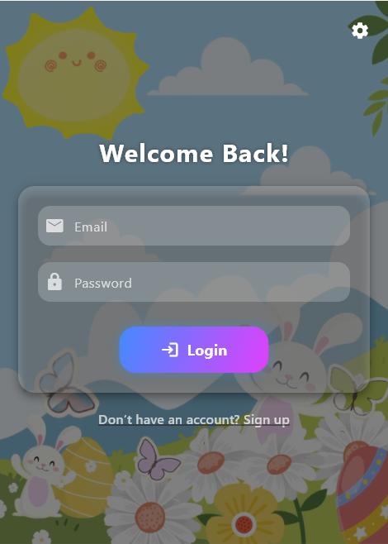
The Login screen welcomes returning users with a clean and friendly design. To log in, simply enter your registered email and password in the provided fields, then tap the Login button. If you don’t have an account yet, tap the “Don’t have an account? Sign up” link below to go to the registration page.
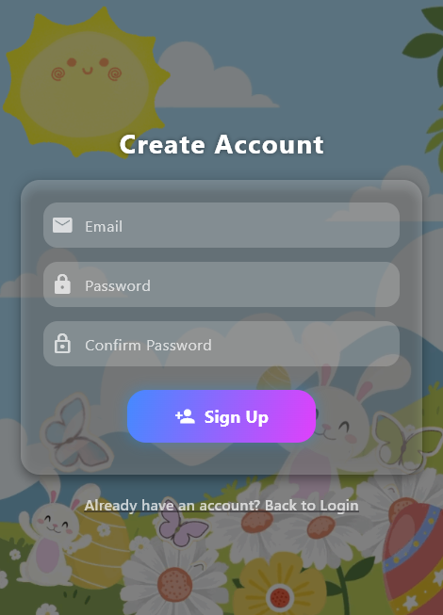
The Sign-Up screen allows new users to create an account. Enter your email, choose a password, and confirm the password in the respective fields. Once filled out, tap the Sign Up button to complete registration. If you already have an account, tap “Already have an account? Back to Login” to return to the login screen.
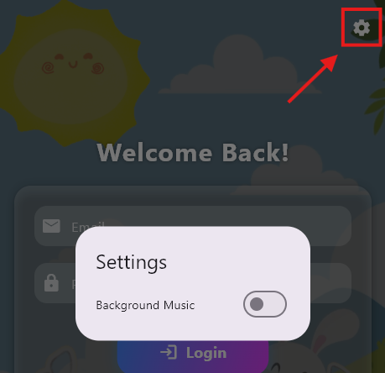
Tapping the gear icon in the top-right corner of the screen opens a Settings popup, where users can toggle Background Music on or off using a simple switch. This allows users to customize their audio experience from the login interface itself.
Profile Creation
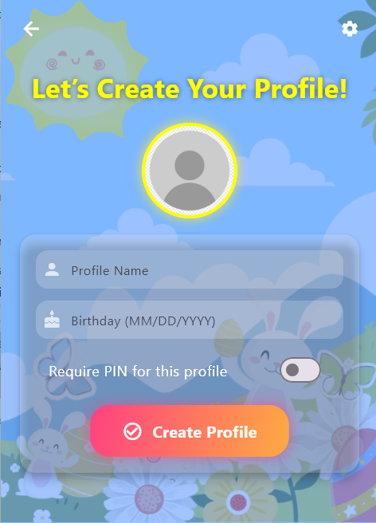
After creating a new account and logging in, you will be taken to the Profile Creation screen. To get started, tap on the “Profile Name” field and enter a name for the profile. Then, tap on the “Birthday” field and type the birthdate in the format MM/DD/YYYY.
If you want to secure this profile with a PIN, toggle the “Require PIN for this profile” switch to the ON position.
Once all information is complete, tap the large “Create Profile” button at the bottom to save and continue. This setup ensures each profile is personalized and optionally protected.
Choosing Profile
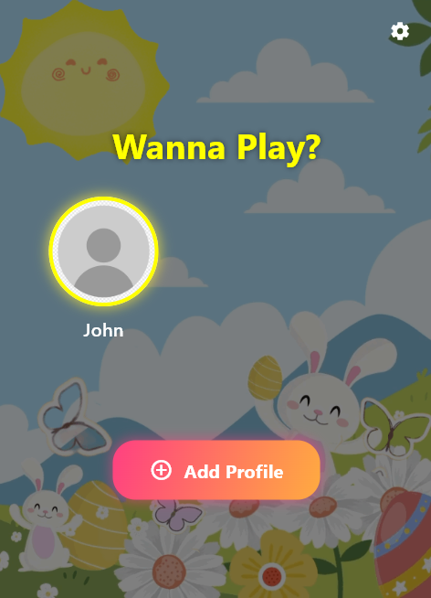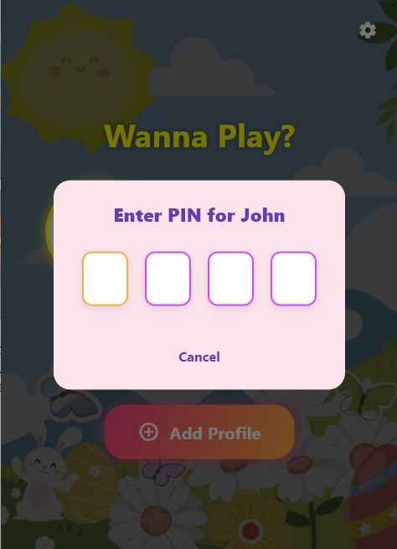
After successfully creating a profile, you will be taken to the “Wanna Play?” screen.
To continue, tap on the profile icon with your name (e.g., John). If a PIN was set for the profile, a PIN entry screen will appear.
On the “Enter PIN for [Name]” screen:
- Tap each box to enter the 4-digit PIN for the selected profile.
- If you enter the correct PIN, you’ll be logged into that profile.
- If you want to go back or cancel, tap the “Cancel” button below the PIN boxes.
To create another profile, simply tap the “Add Profile” button below the existing profiles.
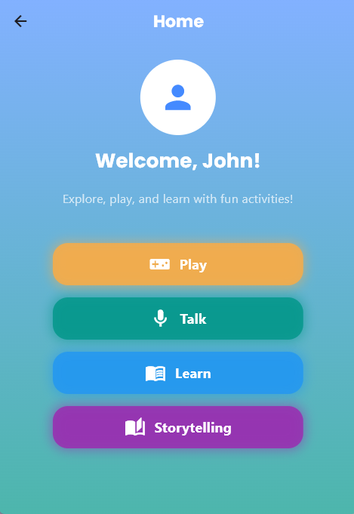
Once the correct PIN is entered (or if no PIN is set), the user will be taken to the Home screen. The screen will greet the user by name (e.g., “Welcome, John!”) and display a message: “Explore, play, and learn with fun activities!”
From here, the user can choose from four main activity buttons:
- Play – Tap this to start games and interactive fun.
- Talk – Tap this to engage in speaking and pronunciation activities.
- Learn – Tap this to begin educational lessons and activities.
- Storytelling – Tap this to explore stories and interactive reading content.
Play Category
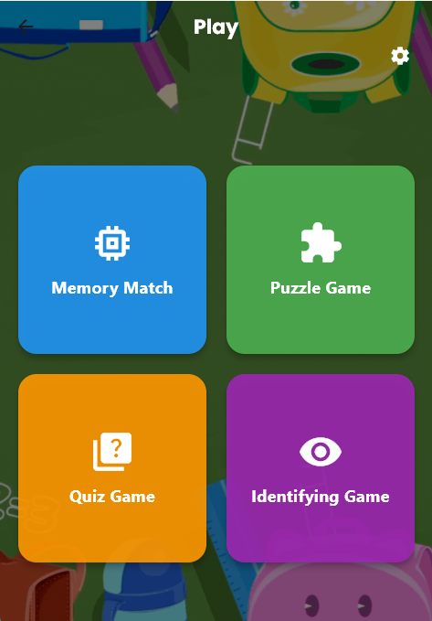
When the user taps the “Play” button from the Home screen, they are taken to the Play Menu, where they can choose from four fun and educational mini-games designed to develop various cognitive skills. Each game is presented as a large, colorful button for easy selection:
- Memory Match (Blue) – A matching game that enhances memory and focus by having users find pairs of identical cards.
- Puzzle Game (Green) – A logic-based game that challenges players to arrange tiles in order, improving problem-solving and sequencing skills.
- Quiz Game (Orange) – A multiple-choice question game that supports learning through recall and quick thinking.
- Identifying Game (Purple) – A recognition game where users tap on specific letters, objects, or animals to strengthen visual identification and vocabulary.
The back arrow in the top-left corner lets users return to the Home screen, while the gear icon in the top-right opens the settings menu. The design is colorful, child-friendly, and intuitive—encouraging young learners to explore and play independently.
Talk Category
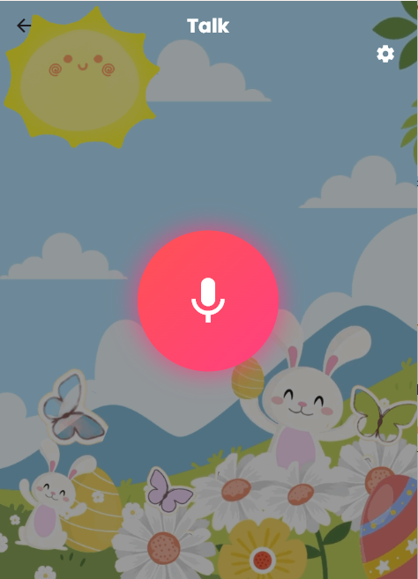
When the user taps on the “Talk” button from the Home screen, they are brought to the Talk interface. This screen is designed to allow children to practice speaking and receive responses powered by AI.
At the center of the screen is a large glowing microphone button. To begin, the user simply taps the microphone button and starts speaking. The app listens, processes the spoken words using AI, and provides a real-time or delayed response—this may include voice feedback, pronunciation evaluation, or simple conversational replies.
This interactive feature helps users improve their speech, confidence, and communication skills in a fun and friendly environment. The back arrow in the top-left corner lets users return to the Home screen, while the gear icon in the top-right provides access to settings (e.g., background music toggle).
Learn Category
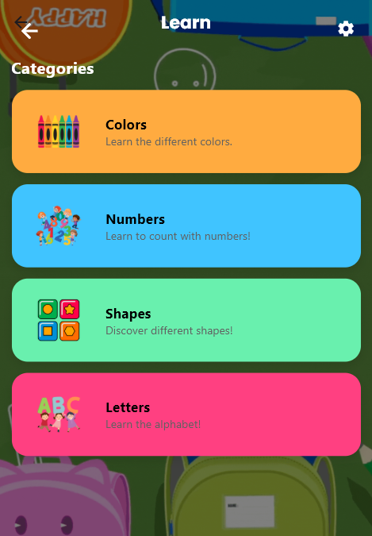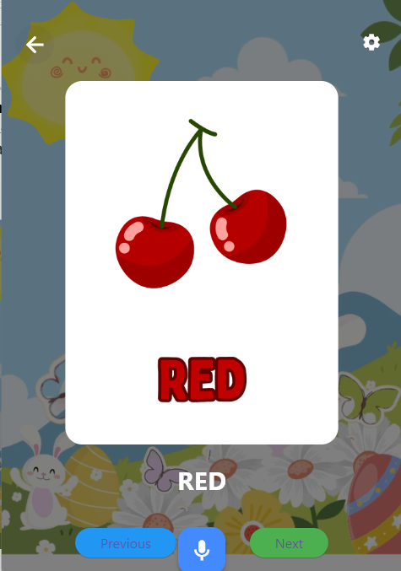
After selecting a learning category (such as Colors, Numbers, Shapes, or Letters), the user is brought to a flashcard viewer where learning becomes interactive and voice-supported.
Each flashcard displays a large image and a bold word describing it (e.g., “RED” with cherries). As the card appears, the app automatically reads the word aloud, helping children connect visuals with pronunciation.
At the bottom of the screen:
- Tap “Previous” (blue button) to go back to the previous flashcard.
- Tap “Next” (green button) to move forward.
- Tap the microphone button in the center to practice saying the word aloud. This feature allows the app to listen and possibly give pronunciation feedback (if supported).
The back arrow at the top-left lets users return to the category screen, and the gear icon in the top-right opens settings. The bright visuals, voice narration, and speech interaction create a fun and immersive learning experience for young users.
Storytelling Category
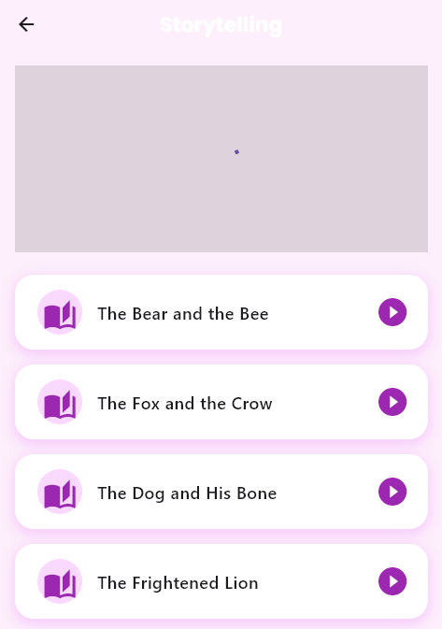
When the user taps the “Storytelling” button from the Home screen, they are brought to the Storytelling interface, where they can listen to a variety of narrated short stories.
At the top of the screen is a story preview area, which displays a visual or animation related to the currently selected story.
Below it is a list of story titles, each with:
- A storybook icon to represent it visually.
- A play button on the right side to start the narration.
To listen, simply tap the play button beside any story (e.g., “The Bear and the Bee”). The story will begin playing with audio narration, allowing children to enjoy the tale while reading along.
Parental Controls and Other Settings
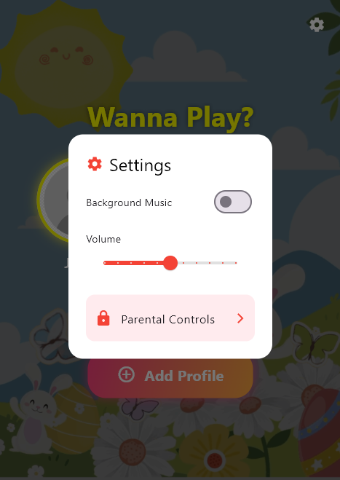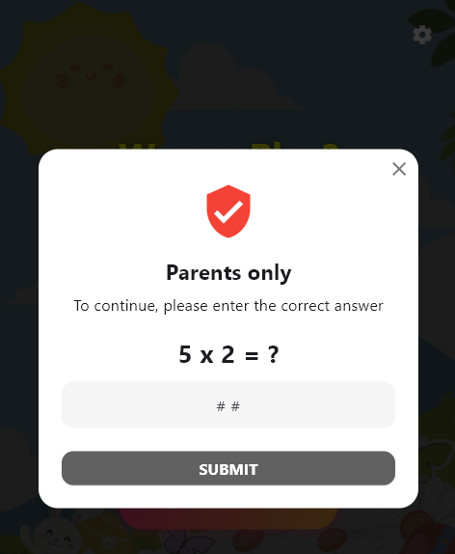
Once logged in, tapping the gear icon opens the Settings menu, where users can toggle Background Music, adjust Volume, and—if logged in—access Parental Controls.

When Parental Controls is tapped, a “Parents only” verification popup will appear. To continue, the user must solve a simple math problem (e.g., 5 × 2 = ?) and enter the correct answer in the input field.
This child-proof security check ensures that only adults can access sensitive settings such as screen time limits, content restrictions, or profile management. After entering the correct answer, tap “Submit” to unlock access.
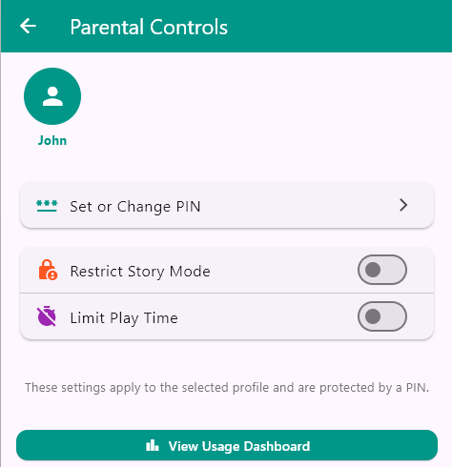
After correctly answering the parent verification question, users are granted access to the Parental Controls screen. This section allows adults to manage safety and usage settings for the selected child profile (e.g., John).
The screen provides the following options:
- Set or Change PIN: Tap this to assign or update a 4-digit PIN for the child’s profile. This adds an extra layer of protection when accessing the profile.
- Restrict Story Mode: Toggle this switch ON to limit access to the storytelling feature. This is useful if you want to control content availability.
- Limit Play Time: Toggle this switch ON to enable time-based restrictions for gameplay. This helps promote healthy screen time habits.

